From: https://www.davidstockmanscontracorner.com/the-cult-of-the-dow-and-the-folly-of-gdp-calamity-howling-part-2/
Date: 20200325 Wednesday

The Cult Of The Dow And The Folly Of GDP-Calamity Howling, Part 2
When you consider Washington’s lightning rush to enact this $2 trillion Everything Bailout and the real purpose of its coast-to-coast soup lines, there is but one unassailable conclusion.
Namely, that this monstrosity is designed to defibrillate the stock market with a fiscal electro-shock and to deliver enough Fake GDP to virtually fill 100% of the temporary Covid-19 hole in the American economy ASAP, if not before.
That way, of course, the Wall Street speculators and Washington pols alike can pretend that all is fixed and that America’s
- 30-year fantasy of debt-fueled prosperity on main street and
- hideously inflated asset bubbles on Wall Street
can go on as if nothing at all has changed.
In truth, everything has changed. In short order it will be evident that the fiscal and monetary bazookas that Washington is now firing wantonly on the American economy will debilitate the patient for years to come—if not permanently so, owing to the gargantuan pre-existing fiscal and economic burden of the Baby Boom which is retiring en masse during the 2020s.
So the questions recur.
- Why the insane rush to judgment, which had the Speaker of the House proposing to spend $2 trillion via a voice vote on a 1200 page bill absolutely no one had read?
- And why does the temporary, one-time Covid-19 hole in the quarterly GDP need to be filled in the first place?
We will endeavor to answer these questions in this and future installments, but here’s the spoiler alert: The cult of the Dow and its helpmate in the GDP print has become so overwhelming that every semblance of rational economic thinking and deliberative review has been obliterated. These monkeys in both the central banking and fiscal branches of Washington are now just scratching their armpits and screeching loudly in knee-jerk fashion in response to the flickering lights of the stock market ticker.
Start with the insanity of enacting instantly a sweeping bailout that was not even on anyone’s radar screen just 15 days ago. So why in the world can’t they spare another 15 days to at least find out what’s in it, and amend it if necessary, before heavily mortgaging taxpayers permanently and setting policy precedents that will make future fiscal governance virtually impossible (i.e. no bailout stone will ever go unturned).
The claim that millions of shutdown-impacted workers are going to be left without food on their table and a roof over their heads next week is just patent tommyrot.
After all, these Covid-19 lay-offs are only days old. For the week ending as recently as Saturday March 14, in fact, the number of initial unemployment insurance (UI) claims was just 281,000. That number happens to be nearly an all-time low and reflects the level that existed way back in June 1974 when the US labor force was 92 million versus 164 million today.
That’s right. So do these knuckleheads really believe that the 2 million or so workers who were suddenly laid off last week and have filed for benefits (as will be reported Thursday morning) are already out of cash? Or that the 60% wage replacement they will get from the regular Federal/state unemployment insurance programs will not be enough to pay their mortgage, car payments or grocery bill for even a couple more weeks?
No, the purpose of rushing to add $600 per week on top of normal UI benefits and disperse a $1200 check to nearly every adult person in America is to assure the stock market gamblers that the household Energizer Bunnies won’t miss a beat in doing their job to spend, spend, spend—and thereby keep the GDP number rising and profit forecasts and stock prices heading ever higher.
To be sure, Bernie and his socialist horde undoubtedly do think this is about social justice and humanitarian endeavor, but on their own they couldn’t muster the votes to send roughly $550 billion on enhanced UI benefits and $1200 per person checks to everyone in a month of Sundays.
This massive eruption of free stuff is happening, in fact, only because the GOP has embraced bailout economics lock, stock and barrel. And their crocodile tears for laid-off workers have nothing to do with it.
McConnell and the rest of his pathetic lot have shit-canned their historic bedrock principles of
- free markets and
- fiscal rectitude
because they think enabling workers to spend at nearly 100% of their prior rates will be good for the stock market, excellent for their stock-owning contributors, and thereby conducive to GOP election prospects come next November.
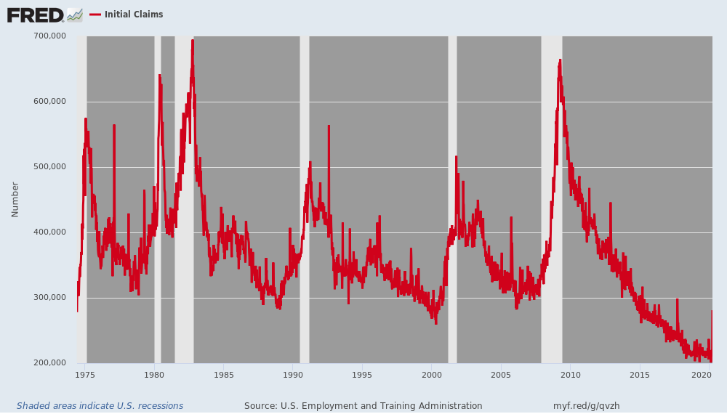
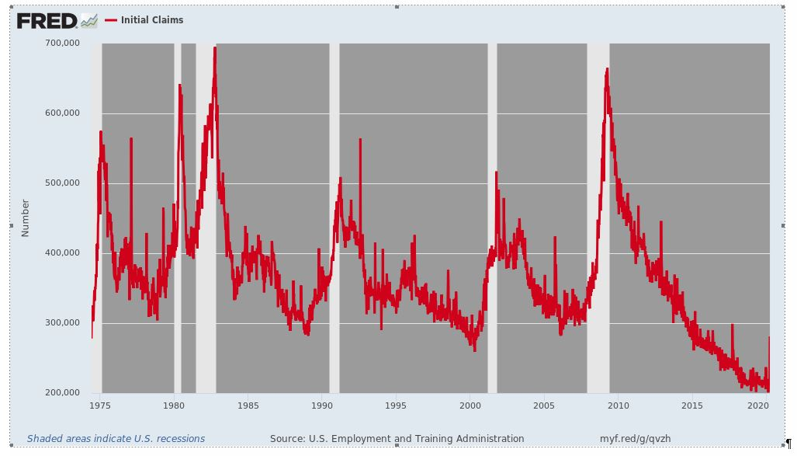
In other words, we are looking at the crassest kind of unprincipled opportunism imaginable. The only thing that matters to the Donald and the GOP is the level of the Dow index between now and November 3. And they are literally selling America down the fiscal drain and embracing what amounts to Ersatz Socialism to rescue it from the 35% swoon of the last 30 days.
So let’s start with the fundamental economics of what is a severe but short-term supply-side shock. That is, the temporary separation of workers from their workplaces and the paychecks which flow therefrom by the Covid-19 fighting public health orders.
In the almost certain likelihood that everyone will be back to work in 4-5 months (apparently in China it is taking less than 2 months to re-open the factories and stores). So in what amounts to just an extended Economic Spring Break, would it really make sense for workers to borrow 100% of their lost paychecks (less UI benefits) during the interim in order to keep spending at 100% of their pre-Covid rate?
Self-evidently, it would not. Prudent workers would sharply pare their spending habits to essentials like food, rent, health care, groceries and loan payments while they are sheltered in place and can’t go to restaurants, bars, movies, the ball park, the mall, the gym, the bowling alley, night school, Disneyland, the race track, the casino or even church, anyway.
That is to say, a one-time shrinkage of discretionary spending and tapping of savings to cover a finite period of income loss for the vast majority of workers makes all the sense in the world, and is actually happening all across America as we type. (We deal with the needy and cashless households in Part 3).
So why in the hell should Congress borrow the money from future taxpayers, instead? Why should the state fill a temporary income and spending hole when the overwhelming share of present day workers would surely tighten their belts for the duration of the emergency rather than take on more debt to spend on things they can’t even buy?
Those questions get to the essential folly of the entire $2 trillion bailout monstrosity. It is simply designed to snatch from thin air via Fed monetization of the massive amounts of new debt to be issued the cash needed to fund a 100% GDP replacement program both at the household and business level.
That’s why the bill also pumps $850 billion into the coffers of small business, medium business and big business to insure that they keep paying workers who are not working, vendors who are not supplying parts, utilities who are not supplying fuel etc.
Back in the day, the old saw about the stupidity of Keynesian economics was that to maintain the illusion of GDP growth and full employment, the professors would be willing to pay workers to dig holes with teaspoons and then fill them back up with the same.
Well, that’s the essence of the Trump/McConnell/Schumer/Pelosi deal—-with a bow wrapped around it by Trump’s new chief of staff, the Big Government-hating, former Freedom Caucus head, Rep. Mark Meadows.
These geniuses are borrowing massively from future tax-payers to fill up a temporary economic hole that will be little noted nor long-remembered in the GDP statistics 10 years from now, or even two years down the road. Yet why, again, do we need all that phony debt-funded GDP in Q2-Q4?
Simple. The so-called Wall Street economists and strategists need 100% GDP replacement so they can make the case to BTFD!
We will deal with
- the 160 million Americans who live off social security and means-tested transfer payments in Part 3 and also
- the millions of very low wage, essentially part time job slots that are likely to bear the brunt of the layoffs, but which are essentially second-earner and second-jobs in households with other sources of income.
But when it comes to primary breadwinners holding reasonably full-time jobs, there is really no case for all of this borrowed income replacement at all.
That’s because America has long had in place a system of 26-weeks of unemployment insurance (in virtually all states except the likes of Alabama and Wyoming) that pays 60% or more of former wages, and that’s more than enough safety net for most workers who find themselves temporarily on working/income/spending quarantine.
For instance, when the Wall Street meltdown hit during the 2008 recession, the UI rolls soared almost instantly as millions of workers filed for benefits. As shown below, continuing claims stood at 2.634 million during the last week of November 2007 before the recession officially commenced in December.
But by December 27 the next year, the rolls had climbed to 4.679 million, and as the post-Lehman flurry of lay-offs continued over the winter and spring, the UI rolls hit 6.539 million by May 16, 2009.
Folks, that’s the so-called automatic stabilizer that’s been a feature of the US labor market for nearly three-quarters of a century. It’s in place and functioning at this very moment, and has enormous, nearly instantaneous surge capacity without a red cent from the pending Everything Bailout.
For instance, total UI outlays were $33 billion in 2007 on the eve of the financial crisis. They quickly soared to a peak of $155 billion in 2010 and then tapered off to $93 billion as the economy recovered in 2012, shrinking steadily thereafter to just $28 billion in the year just ended (FY 2019).
Needless to say, that number will now erupt skyward for the duration of the Covid-19 shutdown without any congressional action at all, and has another salient virtue in the context of the current give-away spree, as well.
To wit, in at least rough form the Federal/state UI program is structured as insurance against loss of income owing to any reason except being fired for cause. Accordingly, employers technically pay the premiums but the cost effectively comes out of a worker’s total compensation package including employer paid benefits.
In a word, the vast majority of breadwinners in the US labor force are already insured against Covid-19!
The fools in Washington are just gilding the Lily by topping that off with $600/per month of additional UI and a $1200 checks for all.
These topping off checks, of course, will cost upwards of $550 billion and be serviced by taxpayers until the end of time, and for what reason other than the illicit purpose of GDP maintenance and stock market-pumping?
Well, allegedly, it’s to insure that workers can pay for necessities that benefits of up to $504 per week in New York, which is the epicenter of the Covid-19 in the US, do not cover.
Then again, what’s wrong with dipping into savings for a few months? As we will show in Part 3, the US has become a hand-to-mouth economy, but even middle income breadwinners have thousands of dollars of rainy day funds and cash savings that could be deployed during the emergency at hand.
Needless to say, the notion that they can’t afford it and Uncle Sam can is risible nonsense as an empirical matter.
And it's downright socialism as a matter of policy and principle.
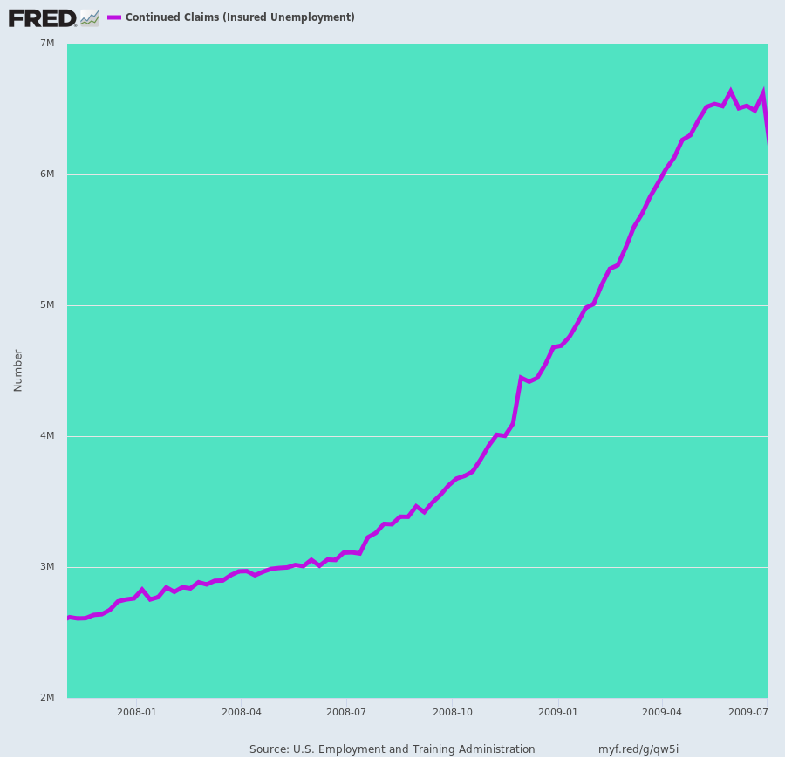
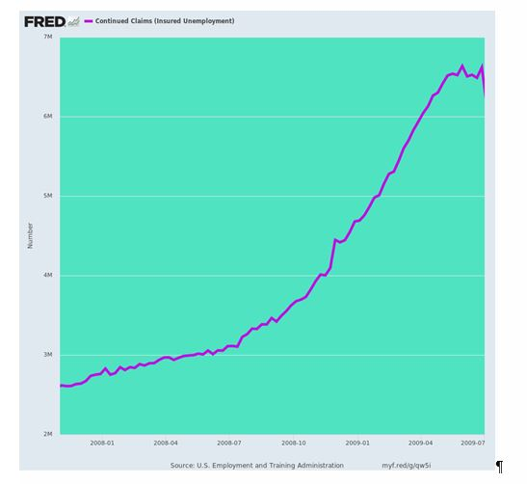
In Part 3 we will deal with low-wage part time workers, the nation’s massive $1.0 trillion means-tested transfer payment system and the 61.3 million current beneficiaries of social security retirement and disability insurance.
The whole system adds up to $2.5 trillion per year, and not a dime of it will be reduced by the Covid-19 shutdown, yet virtually all of the 160 million beneficiaries in the Welfare State system will be eligible for the $1,200 gift to adults and $500 to minors.

